CENTRAL REGION 5
2021 COLLEGE SCHOLARSHIP APPLICATION

MAIL TO: Scholarships - c/o CSEA Central Region 5, 6595 Kirkville Road, East
Syracuse, NY 13057

SCHOLARSHIP CRITERIA: Including, but not limited to, Academic Standing, Extracurricular
Scholastic & Community Activities, Essay, & References.

- Applicant

Name______________________________________

Address_________________________________________________________________

Phone No. (____)______________________

- High School Name________________________________________________________

High School Address______________________________________________________

High School Graduation Date_______________________________________________

Applicant’s current cumulative high school grade average__________________%

- Region 5 Parent/Guardian/Grandparent Information:

Name of Region 5 Member/Staff________________________________________________

CSEA Local Name & Number____________________________________________

Mother’s Father’s
Name______________________________ Name______________________________

Mother’s Work Location Father’s Work Location

___________________________________ __________________________________

Title_______________________________ Title_______________________________
E-mail: ____________________________ E-mail: ____________________________

- Name and address of college or school, applicant plans on attending: ___________________

___________________________________________________________________________

Has applicant been accepted ______Yes ______No

- Other Scholarships

Name: _______________________________Amount: _____________

Annual: _______________ or one-time award: ____________________

Name: ______________________________ Amount: _____________

Annual: ______________ or one-time award: ____________________

- List organizations and/or extracurricular activities: __________________________________

__________________________________________________________________________

__________________________________________________________________________

__________________________________________________________________________

- One letter of reference from a teacher at your high school.

- Essay of 250-500 words on “What Union membership has meant to my family”.

- Transcript: A current OFFICIAL high school transcript must be attached to this
application. Take this completed application to your school’s guidance office
and have THE SCHOOL mail the completed application along with the transcript, essay and letter of reference.

FILING DEADLINE: Applications accepted until May 1, 2021.

All information is confidential and will become the property of CSEA Central Region 5.

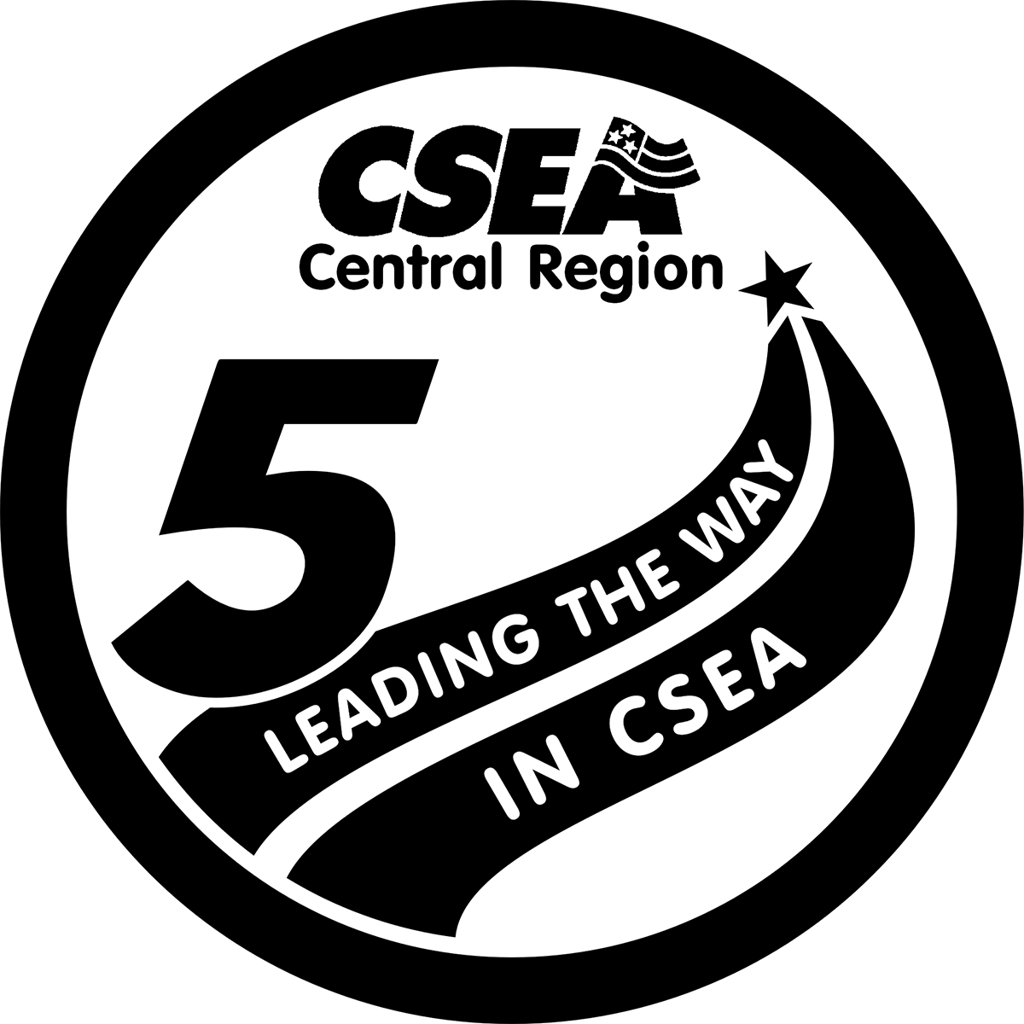
Kenny Greenleaf, President

