A message from Central Region 5 President Kenny Greenleaf December 2022

“Stay United”
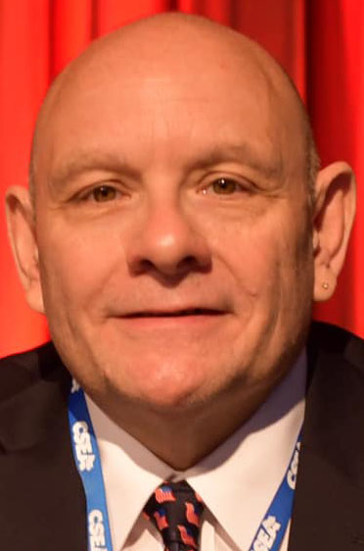

Hello and Happy Holidays, Central Region 5 sisters and brothers!

In a number of ways, this has been another tough year. But there have been some glimpses of hope along the way. I can’t thank everyone enough for their resilience and hard work throughout the difficult staffing shortages across the state in every field.

I want to congratulate the many activists that have recently retired. Your service and dedication to CSEA and the region has been invaluable. If you have plans to retire soon, please consider “adopting” an activist so your knowledge and union experience can be passed down.

A big shout out to everyone that donated or raised money for our Polar Plunges. We were among the top fundraising teams at both the Binghamton and Oneida Shores plunges. There’s a reason why the Polar Cap Award is a fixture at the Central Region office. We will continue to be strong supporters of the New York Special Olympics and the great work they do.

Many of you by now have received communications from various anti-union groups. These groups are trying to scam you and your union sisters and brothers by hunting down your personal information so they can inundate you with emails and postcards riddled with misleading statements about your union.

These groups are using divisive issues to get attention to get you to click on a link in an email or fill out a postcard with your personal information. When they get your information, there’s no telling what they will do with it. DO NOT SHARE YOUR PERSONAL INFORMATION.

These groups are determined to go after your union-protected contract to lower your wages, cut your benefits, eliminate your pension, and leave you without proper representation. Together, standing united, we will make sure that doesn’t happen.

“When I make a fist, it’s strong, and you can’t tear it apart. As long as there’s unity, there’s strength.” – Ara Parseghian (Notre Dame Football Coach 1964-74)

When we stay united as a labor union, we’ll always be strong enough to never get pushed down and always fight back.

I am proud to be a member of CSEA. I am proud to be a leader in such a strong labor organization. But it will take every one of us, united, to keep our union strong.

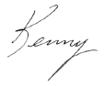
In Solidarity,

Kenny Greenleaf
Central Region 5 President

