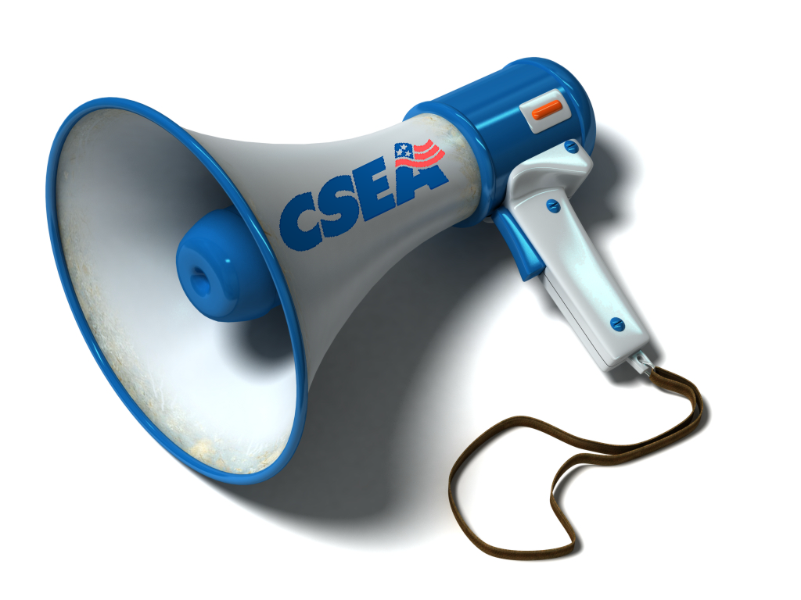
Top ways to utilize CSEA
Communications Specialist
Nick Newcomb

- Invite to your workplace for on-the-job workplace portraits, for use in the CSEA Calendar, the Work Force or the Region web site
- Get coverage of your stories/issues for the CSEA Work Force that you believe have statewide relevance/importance or meet our coverage guidelines
- Get help putting together your Local or Unit’s Communications Plan
- Get assistance with writing letters to the editor, speeches, talking points, and
other leadership/member communications
- Arrange for email blasts to your membership
- Get CSEA bulletin board materials and flyers (all documents can be found on cseany.org/r5)
- Get training on how to develop a union newsletter, website, or social media presence
- Help develop, promote, and publicize your union Community Service projects or events
- Work with your LRS, leaders and activists to plan your communications strategy when dealing with an issue-based campaign, i.e., contract, privatization, layoffs, budget, etc.
- Get media coverage of your union event or issue
- Act as spokesperson to reply to media inquiries or as a liaison to put the right people in touch with reporters locally
- Put together flyers or posters to promote your union event
- Notify immediately of any serious injury/death of any member while working
- Call to volunteer to work at CSEA's booth at the New York State Fair!!
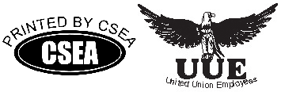
You can call/text Communications Specialist Nick Newcomb at (315) 414-7744, call office at 1-800-559-7975, ext. 3375, or by e-mail at nicholas.newcomb@cseainc.org

